PermitAIO
Tech Roles & Manager Dashboard
A step-by-step guide to setting your tech identity, viewing team workload, and managing job assignments

Overview
The Jobs dashboard now understands who’s who on your team. Every permit tech and HOA tech can tell the dashboard which one they are, then filter to see only their own jobs. Owners, Admins, and Managers get an additional Team Status panel showing active workload across every tech, and can reassign any job to a different tech directly from the Jobs table.
This guide covers five things you can do with the new roles and dashboard views:
- Set your own tech identity so "My Jobs" shows just your work
- See the Team Status panel (Owner, Admin, and Manager roles only)
- Switch between "My Jobs" and "All Jobs" on the dashboard
- Reassign a job’s Permit tech or HOA tech from the Jobs table
- As the Owner, change a teammate’s role — including granting the new Manager role

Roles at a glance
Role | Sees Team Status | Can reassign job techs | Can change roles
Owner | Yes | Yes | Yes
Admin | Yes | Yes | No
Manager | Yes | Yes | No
Member | No — sees own jobs only | No | No

Step 1 — Set your own tech identity
Every user tells PermitAIO which permit tech and/or HOA tech they are. This is self-service — anyone can set their own identity, and it’s what powers the "My Jobs" filter on the dashboard.
- Open Settings from the left sidebar.
- Find the "My tech identity" card.
- Choose your Permit tech and/or HOA tech from the dropdowns.
- Click Save. You’ll see a "Saved your tech identity" confirmation.
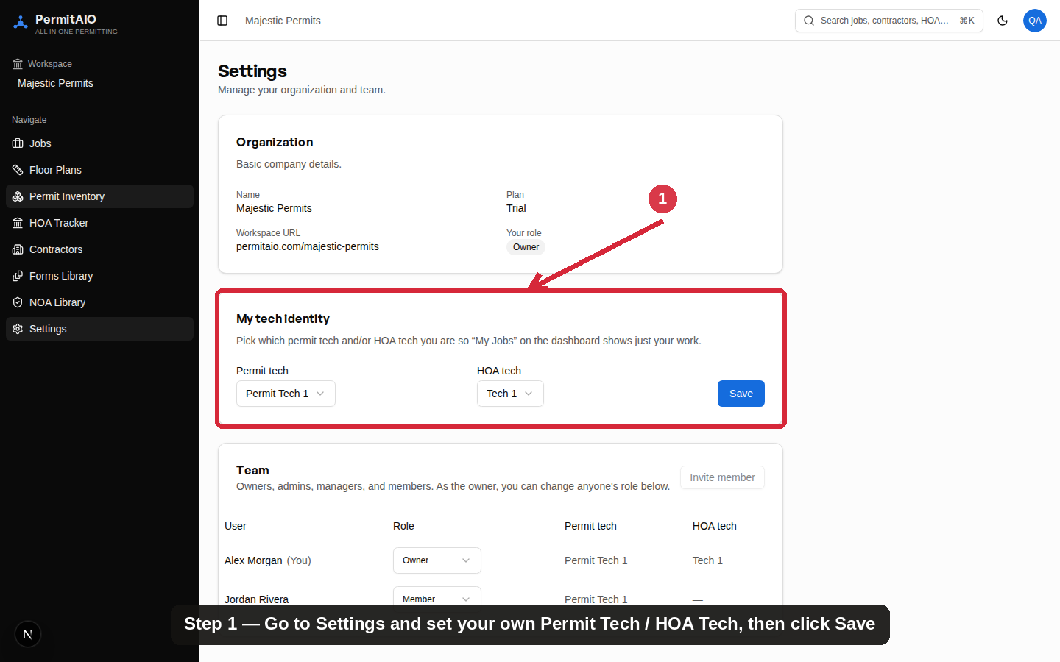
Settings → My tech identity — pick your Permit tech and HOA tech, then Save

Step 2 — Team Status panel
Owners, Admins, and Managers see a Team Status panel at the top of the Jobs dashboard. It shows every permit tech and HOA tech on the team with their active job count and any jobs that need attention — a quick way to see who has bandwidth and who’s backed up. Members do not see this panel; they only see their own job list.
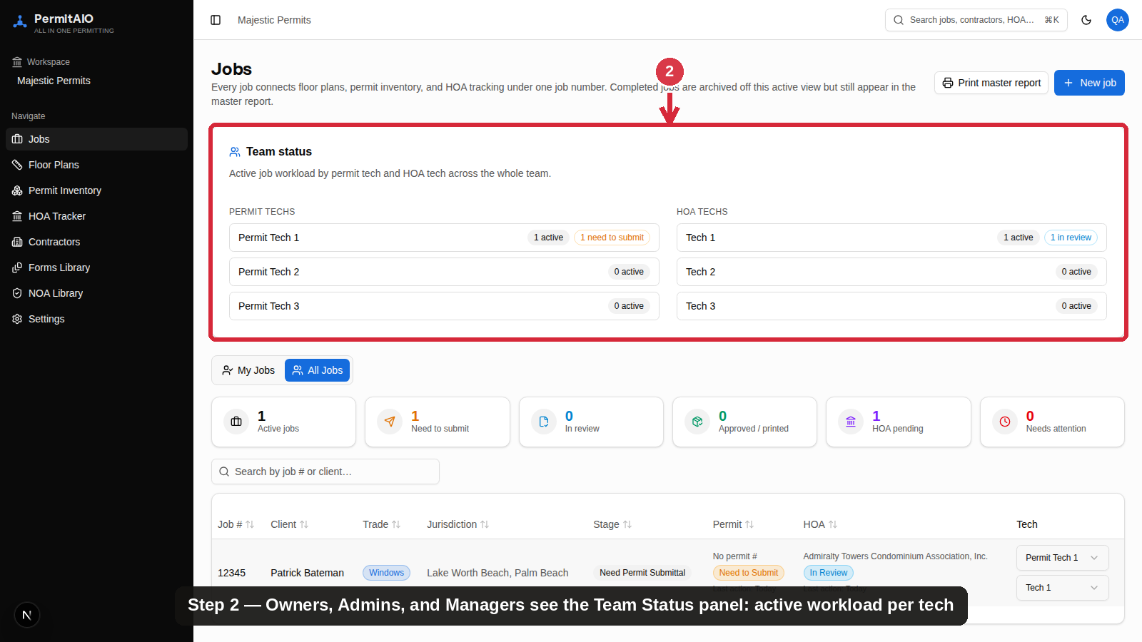
Team Status shows active workload per tech — visible to Owner, Admin, and Manager roles

Step 3 — My Jobs vs. All Jobs
Right below Team Status, every user gets a toggle between "My Jobs" and "All Jobs":
- My Jobs — shows only the jobs where you’re the assigned Permit tech or HOA tech (based on the identity you set in Step 1).
- All Jobs — shows every job in the organization, regardless of who’s assigned. Available to every role, so any tech can see the full picture when they need to.
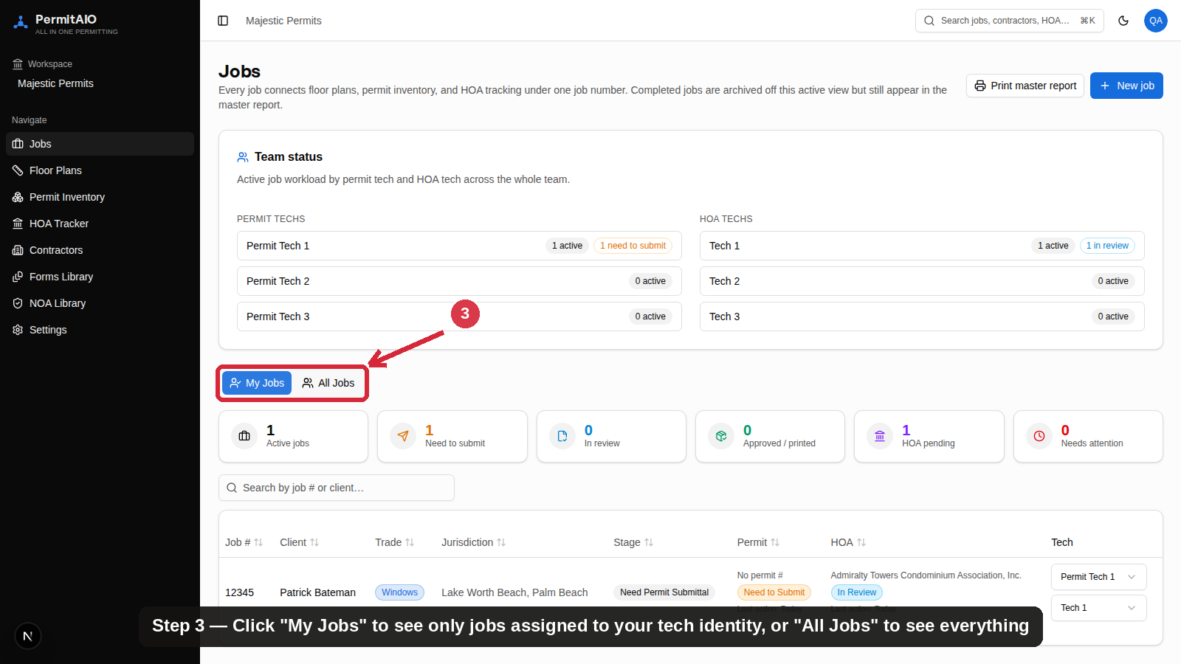
Toggle between "My Jobs" (just your assigned work) and "All Jobs" (everything)

Step 4 — Reassign a job’s tech
Owners, Admins, and Managers can reassign the Permit tech or HOA tech on any job right from the Jobs table — no need to open the job first.
- On the Jobs dashboard, find the job in the table.
- In the Tech column, click the Permit tech or HOA tech dropdown for that row.
- Select the new tech. The change saves immediately and the Team Status panel updates.
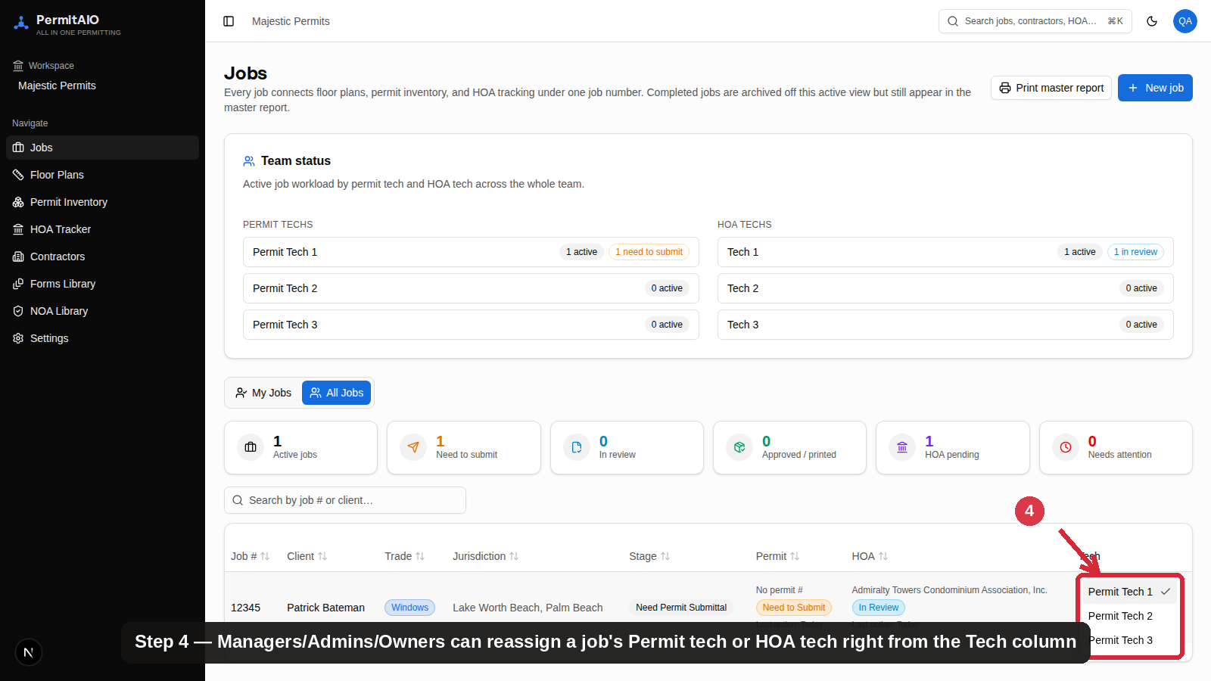
Click the Tech dropdown on any job row to reassign its Permit tech or HOA tech
Note: this reassignment control only appears for Owner, Admin, and Manager roles. Members can see the assigned tech on each job but cannot change it from here.

Step 5 — Changing roles (Owner only)
Only the Owner can change a teammate’s role, including granting the new Manager role. This keeps role changes tightly controlled while letting the Owner delegate day-to-day job assignment to trusted Managers.
- Go to Settings and scroll to the Team section.
- Find the teammate in the list.
- Click their Role dropdown and choose Owner, Admin, Manager, or Member.
- The change takes effect immediately — no save button needed.
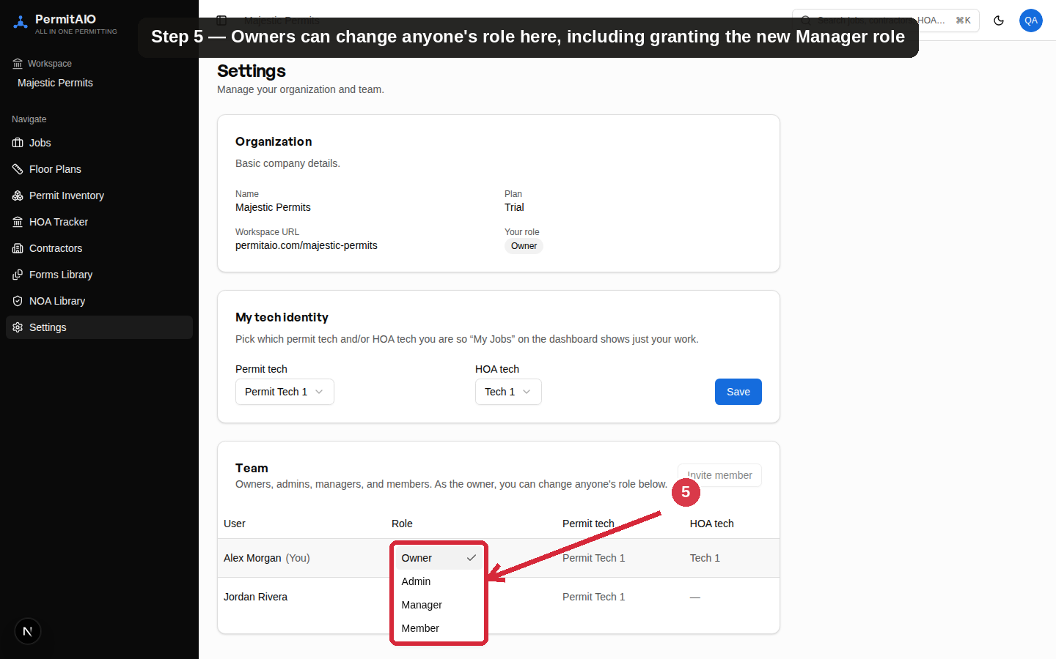
Settings → Team — the Owner can change anyone’s role, including granting Manager

Good to know
- Role changes are restricted to the Owner at the database level, not just hidden in the UI — so this can’t be bypassed.
- Setting your own tech identity is self-service for everyone — no approval needed.
- Job tech reassignment from the dashboard is a convenience layer on top of the existing Permit Inventory and HOA Tracker tools — it does not change how those tools store or report their data.
- Managers have the same day-to-day dashboard permissions as Admins (Team Status, All Jobs, reassigning techs) but cannot change anyone’s role — that stays Owner-only.

